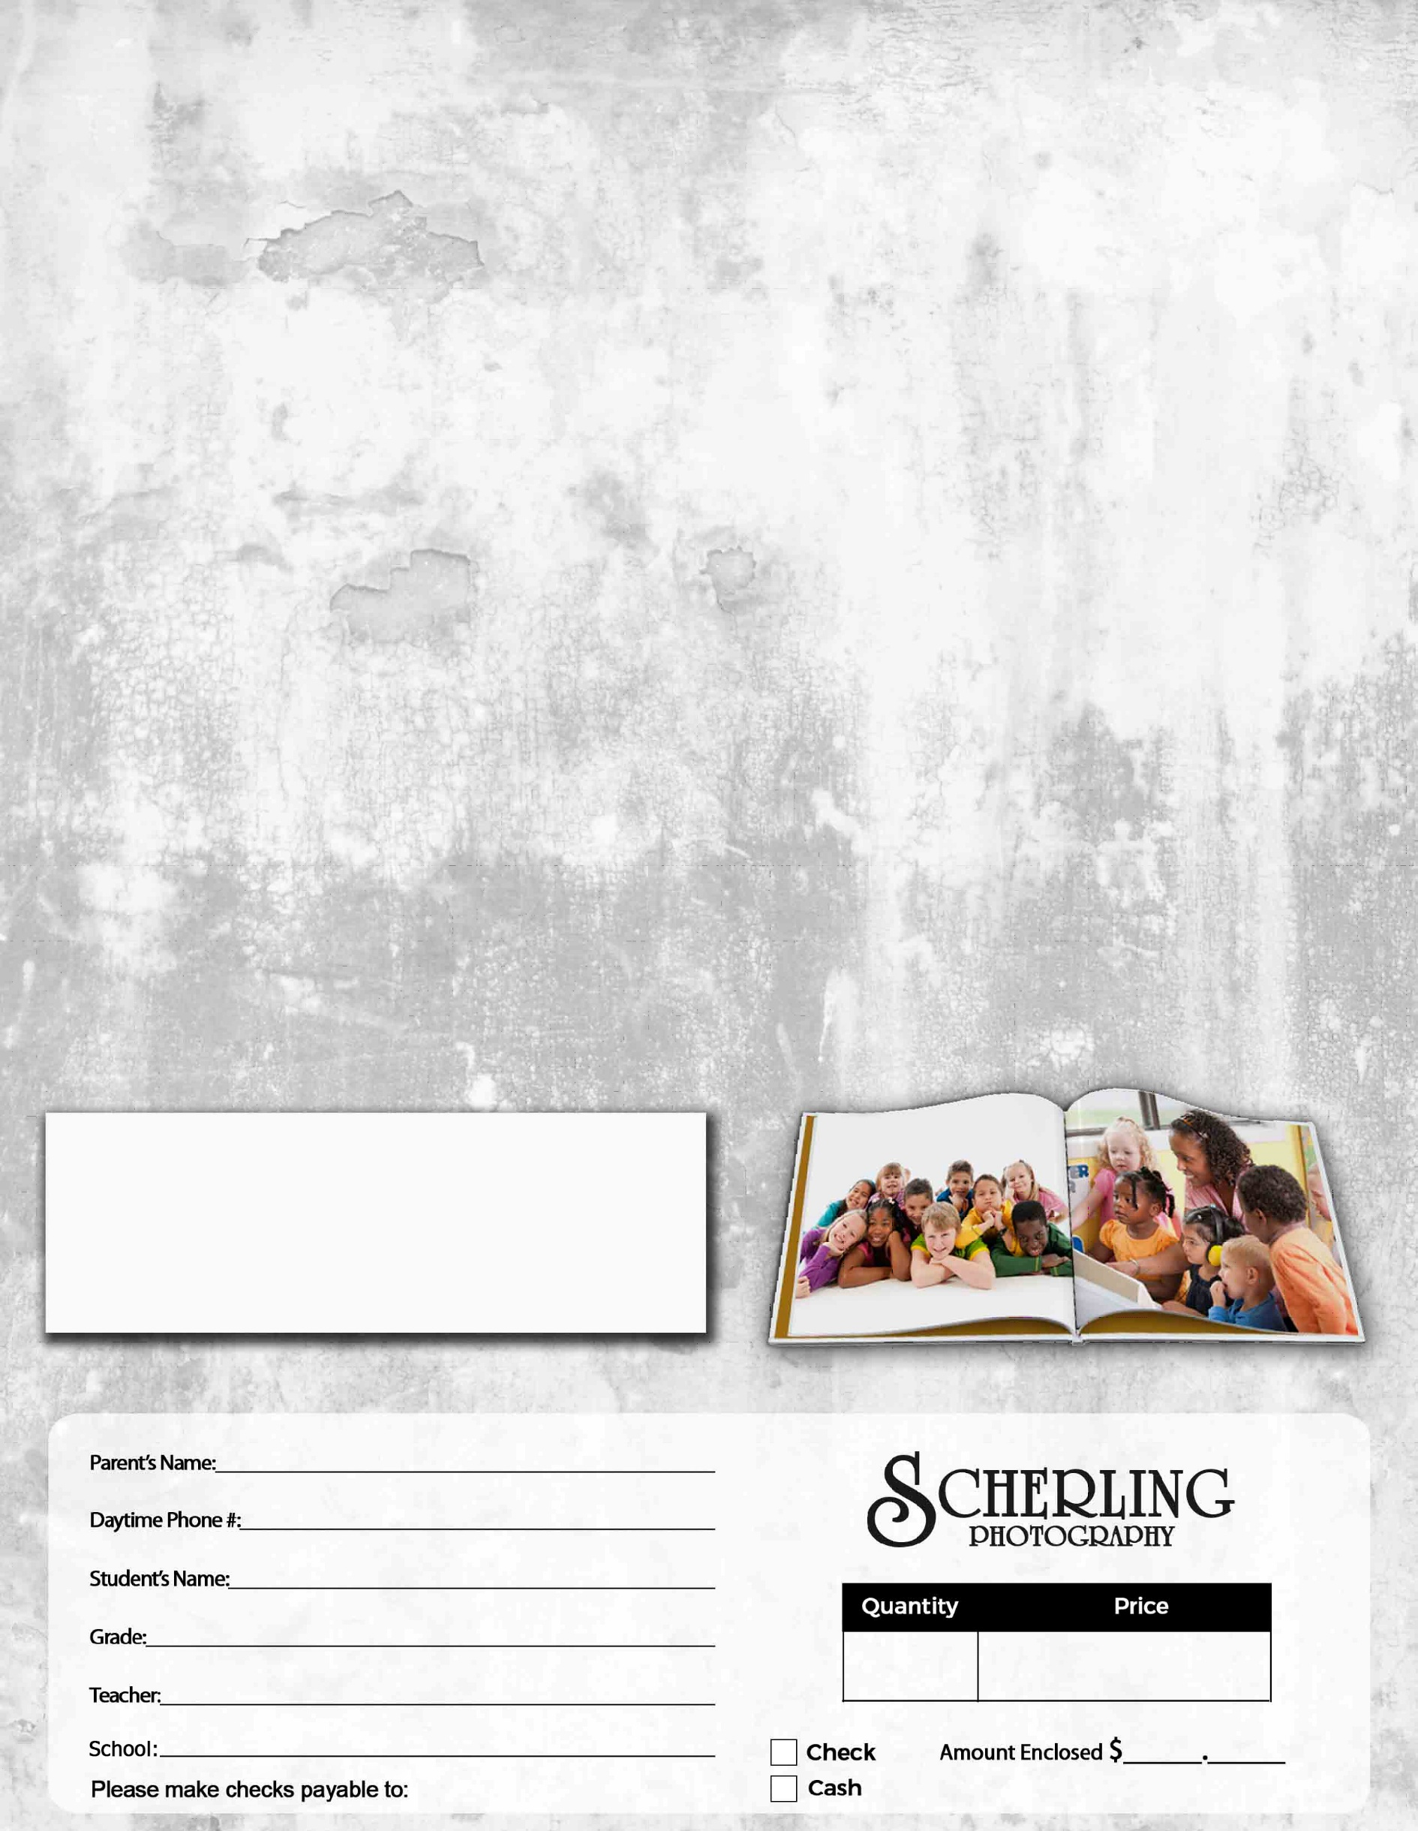
Litchville-Marion Elementary Yearbook 2025-2026
Only $35.00 each
Enclose payment and return to your teacher by:
Friday, May 1st
Please use one envelope per child/order
Additional envelopes are available at the school office.

Make checks payable to: Litchville Marion HS
Exact amount only – no refunds will be issued
Thanks for your order!
Litchville Marion HS

$35.00
Yearbooks = $35.00 Each

