

Online Course Dates: July 24 – August 14
- Period of Travel: 8/1/26-8/10/26
Asahikawa, Japan
Program Summary
This 10-day program is intended explore and investigate a unique array of sustainability, energy production, recycling, agriculture, agri-research, agri-logistics, community farming, food manufacturing, EV / automotive technology, and building conditioning (using snow!), through the lens of a northern Japanese city, Asahikawa.

Admission Requirements
All applicants are required to complete an application form. To be considered for admission, students must meet the following minimum admissions requirements:
- Applicants must be 18 years of age or older as of the program start date. The minimum age requirement is strictly upheld.
- completion of at least 12 hours of college-level coursework;
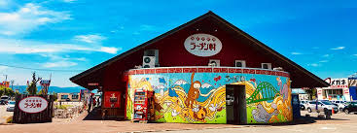
- a cumulative college earned grade point average of 2. 5/4.0 or higher


Academics
Students will enroll in INDP 297: Independent Study (3 credits) focusing on sustainable production.

Cultural Excursions
Hokkaido's second-largest city, Asahikawa, lies to the northwest of the Daisetsuzan mountain range and is a major gateway for exploring Sounkyo Gorge and the Furano area. The city itself has well over 100 rivers flowing through it, a flourishing culture of arts and crafts, and a major zoo. We will explore, temples, a sausage factory – the official sausage of Hokkaido Nippon-Ham Fighters, visit a large snow air conditioning system at the Asahikawa Science Museum, tour city hall and their solar and energy control system, visit a research center for argi research, visit an electrical generator that generated electricity cleanly from non-recyclable waste. And much much more.
Housing and Meals
The cost of housing is included in the program fee and is a hotel within walking distance to downtown and the train station.

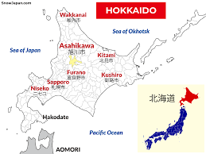

Passport and Visa
Students will need to acquire or have a current
passport before departure. Applicants should
allow at least eight weeks for standard passport
processing. An application and information can be acquired at your local post office or at travel.state.gov.

No Visa is needed for this program.

Pre-Departure Orientation
Participation in a pre-trip orientation is mandatory.
The orientation will be held approximately six to eight weeks prior to departure. Details will be sent upon acceptance.

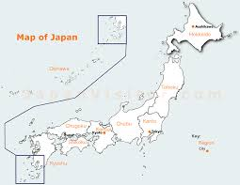

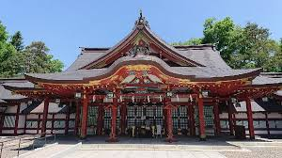
Payment and Deadlines

Participants |  | 5 | 10 | 12
Included Program Costs |  | -Tuition  -Specified Program Activities & transportation  -Accommodations at double occupancy*  -Faculty Liaison & translator  -CISI Insurance+
HCC TOTAL COST |  | $3,680 | $2,760 | $1,804
Additional Student Costs | Flight | ~ $2,600  + Required flight will be reserved & you will pay the travel agent +
Additional Student Costs | Passport | ~$150  +must not expire within 6 months & have 2 consecutive blank pages+
Additional Student Costs | Meals | Limited options for allergies

A $500 deposit, taken off the total program cost, is due with the completed application form and subject to the cancellation and refund policy as outlined in the application.

- application deadline is April 24
- final payment deadline of May 15

Financial Aid applies & there are several scholarships available!

