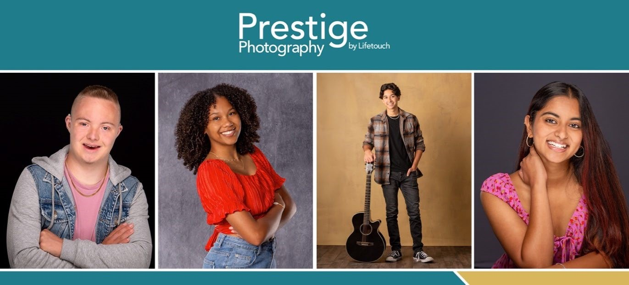
Congratulations, Class of 2026!
It's Time to Schedule Your Senior Portraits!
Date(s): November 4, 2025
Location: Stage in Auditorium
Next Steps: Visit schedule.prestigeportraits.com To locate your appointment code, enter your school’s city and state, and find your school.
Customer Service: 855-918-2930 or mjarea@lifetouch.com
 | Yearbook | Mini | Essential | Most Popular
SESSION FEE | $0 | $20 | $30 | $40
NUMBER OF POSES | 2 | 6-8 | 10-14 | 14-20
NUMBER OF BACKGROUNDS | 1 | 1 | 2-3 | 4-6
NUMBER OF OUTFITS | 1 | 2 | 3 | 4
YEARBOOK REQUIREMENT | Yearbook Tux/Drape will be available and counts as 1 outfit. Cap & Gown will also be available
SESSION DETAILS
For tips about your upcoming session and outfit inspiration, visit prestigeportraits.com.

